**Object Oriented Programming (C&D) – Spring 2020**

**Quiz-03**

Implement following **ComplexNumber** class:

class ComplexNumber

{

private:

int real;

int imaginary;

public:

ComplexNumber();

ComplexNumber(int , int ) ;

ComplexNumber(const ComplexNumber );

~ComplexNumber(); //Does Nothing.

void Input();

void Output();

bool IsEqual(ComplexNumber);

ComplexNumber Conjugate();

ComplexNumber Mult(ComplexNumber);

float Magnitude();

};

**Sample Run:**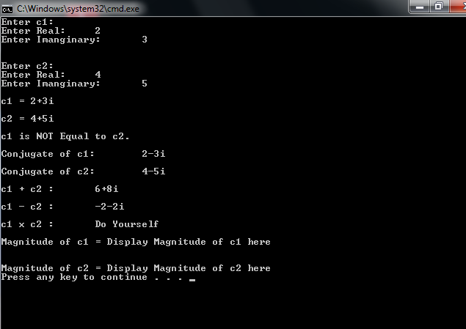

**Important:**

* Do not change class definition
* Submit only one **RUNNING** file YourRollNumber.cpp that contains class, its implementation and the driver Program. Do not submit .rar or .zip files.